Reporte de Reservas del área de Suministros Marzo 2024

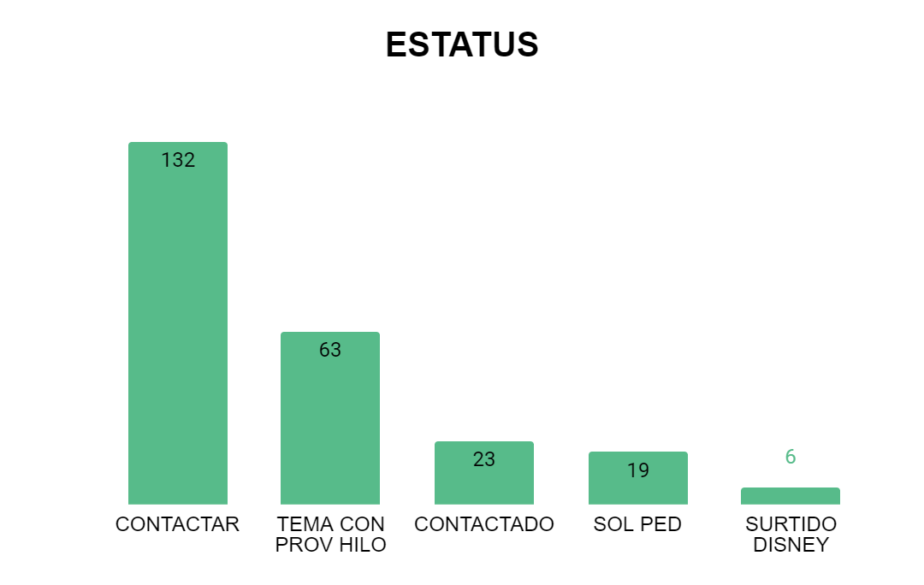

| *ESTATUS* | RESERVA |
| --- | --- |
| CONTACTAR | 132 |
| TEMA CON PROV HILO | 63 |
| CONTACTADO | 23 |
| SOL PED | 19 |
| SURTIDO DISNEY | 6 |
| PENDIENTE | 1 |
| HACER RESERVA | 1 |
| BLOQUEADO | 1 |
| **Suma total** | **246** |

| *CATEGORIA* | ARTICULO |
| --- | --- |
| UNIFORME | 90 |
| ALTERACIONES | 86 |
| ALIMENTOS | 36 |
| INSUMOS DIVERSOS | 9 |
| PAPELERIA Y UTILES | 4 |
| GANCHOS | 4 |
| MANTENIMIENTO | 3 |
| ACRILICOS | 3 |
| ENFERMERIA | 1 |
| BOLSAS Y EMPAQUE | 1 |
| **Suma total** | **237** |

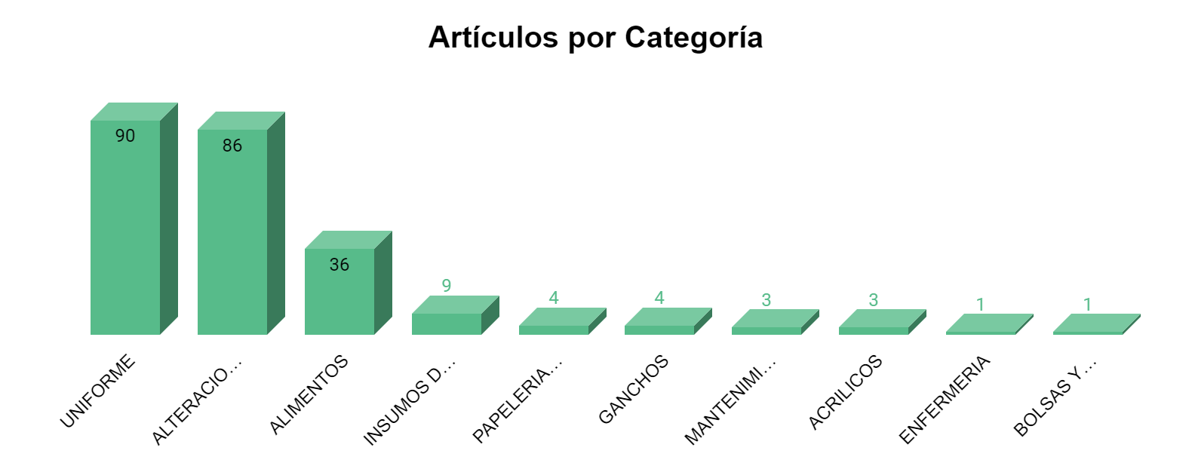

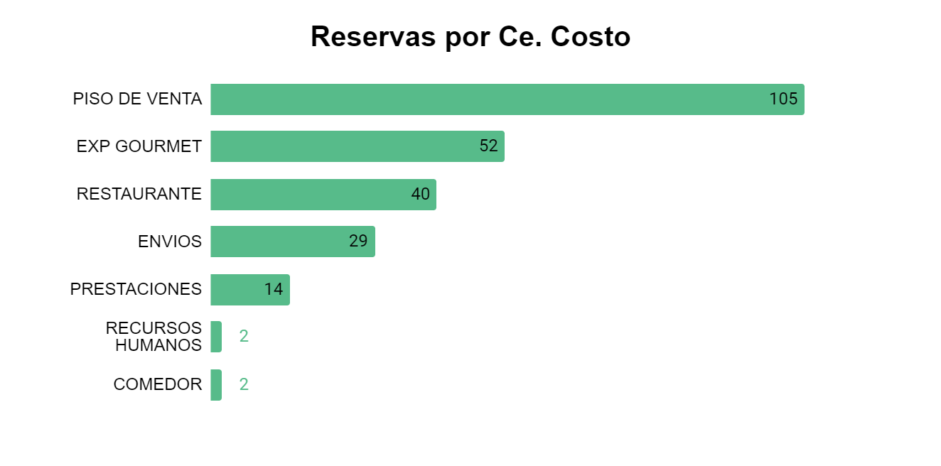

| *CE. COSTO* | RESERVAS |
| --- | --- |
| PISO DE VENTA | 105 |
| EXP GOURMET | 52 |
| RESTAURANTE | 40 |
| ENVIOS | 29 |
| PRESTACIONES | 14 |
| RECURSOS HUMANOS | 2 |
| COMEDOR | 2 |
| MANTENIMIENTO | 1 |
| **Suma total** | **245** |

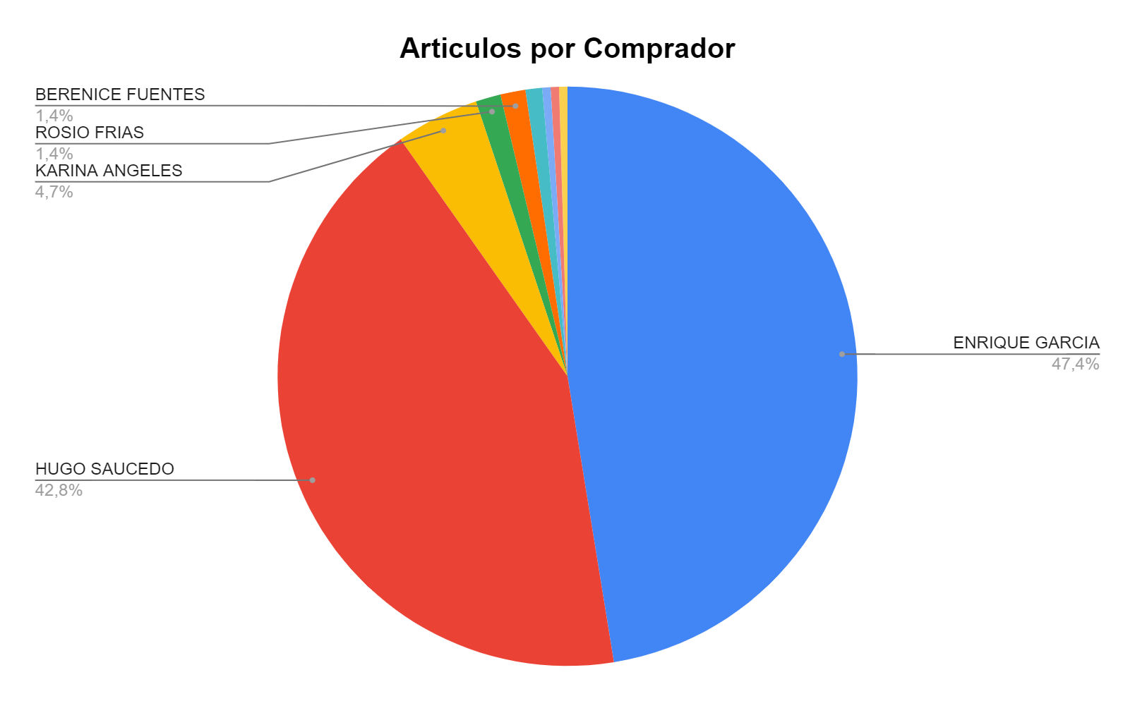

| *COMPRADOR* | ARTICULO |
| --- | --- |
| ENRIQUE GARCIA | 102 |
| HUGO SAUCEDO | 92 |
| KARINA ANGELES | 10 |
| ROSIO FRIAS | 3 |
| BERENICE FUENTES | 3 |
| JUANA MURILLO | 2 |
| KARLA DEL ROCIO | 1 |
| JOSE MEJIA | 1 |
| EMMANUEL PIÑON | 1 |
| **Suma total** | **215** |

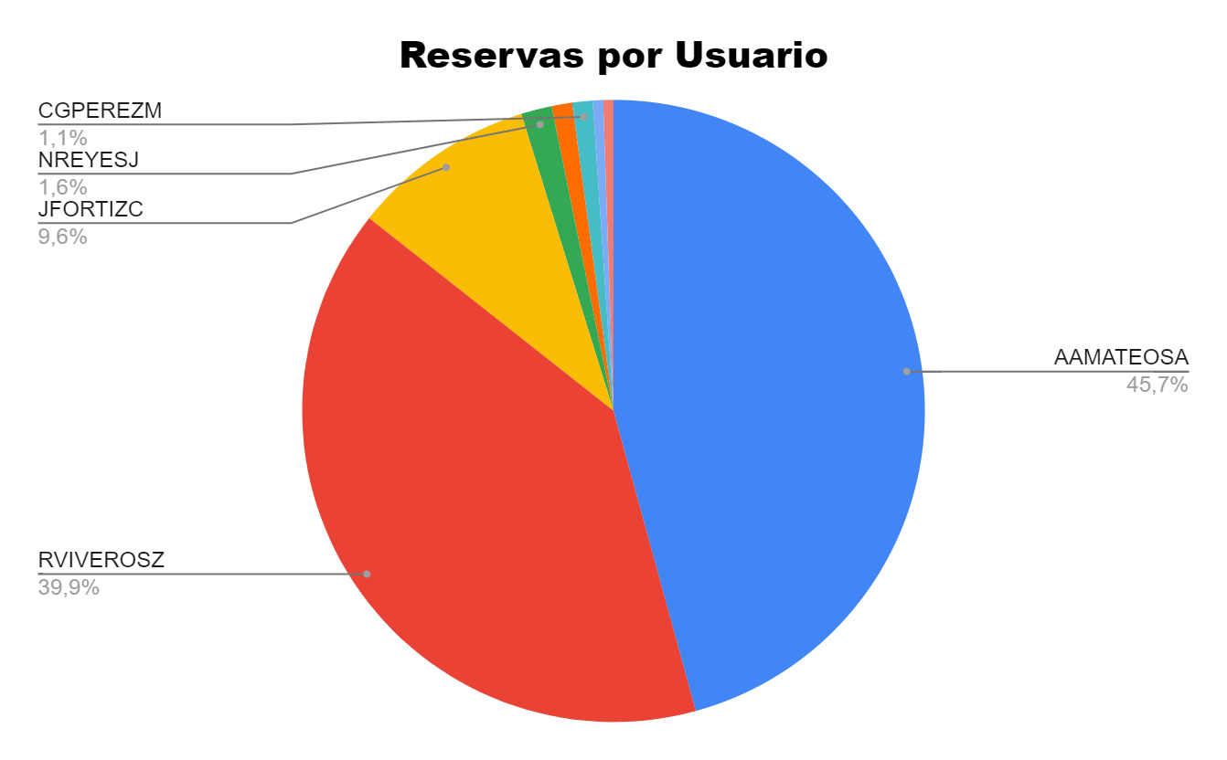

| *USUARIO* | RESERVAS |
| --- | --- |
| AAMATEOSA | 86 |
| RVIVEROSZ | 75 |
| JFORTIZC | 18 |
| NREYESJ | 3 |
| IAGARCIAV | 2 |
| CGPEREZM | 2 |
| FRAYAT | 1 |
| BELUNAC | 1 |
| **Suma total** | **188** |

